Stage 4 – Loco Motive
COURSE DESIGNER: Ryan Christenson

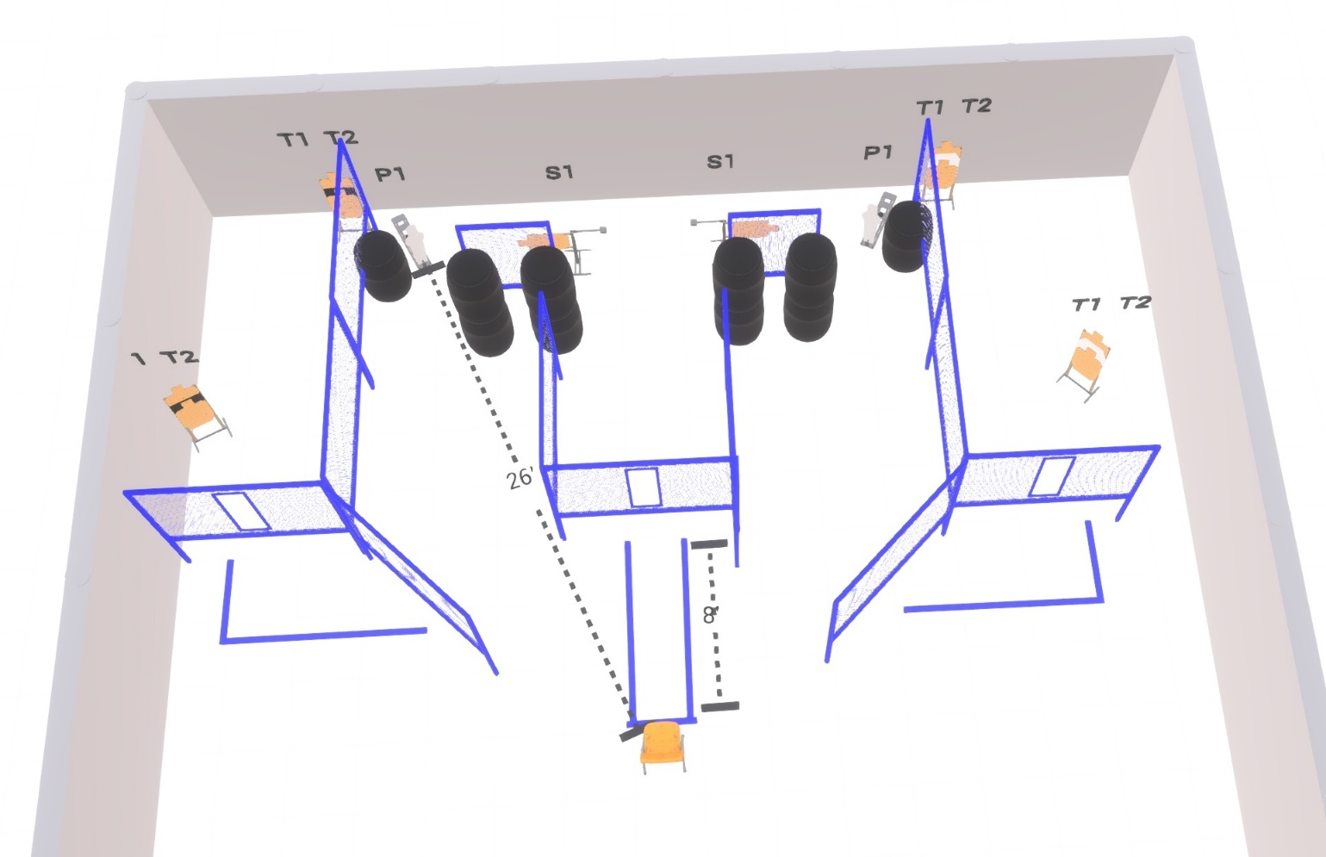

Written Stage Briefing:

Stage 4 – Loco Motive - is a 26 round, 130 point, Comstock Course. There are 12 cardboard targets and 2 steel targets

Starting seated in chair
Handgun is loaded and holstered, palms touching knees
PCC is loaded stock touching belt, weak hand palm touching knee.

On the audible start signal, engage targets from within the shooting area.

USPSA / NROI Range Commands:
- Make Ready
- Are you ready?
- Standby
- If finished, unload and show clear
- If clear, hammer down and holster (Handgun)
If clear, hammer down and flag (PCC)
If clear, cylinder closed and holster (Revolver)
- Range is clear

Setup Notes:
12 Single Wall Stands
4 Double Wall Stands
2 Triple Wall Stands
8 Full Walls
2 Half Walls
2 Port Walls
1 Drop Port Wall
2 Activator Poppers + cables
2 Swingers + sticks
4 Target stands / 8 target sticks
10+ Barrels



